;

**COMP 4320**

**Introduction to Computer Networks**

Project #: Lab 2

Logan Bolton

10/17/2025

# Executive Summary

This report analyzes the behavior of TCP, UDP, and IPv4/IPv6 protocols using Wireshark packet captures and traceroute tests.

# Table of Contents

Table of Contents

Executive Summary 2

Table of Contents 3

1 Part 1 – TCP 4

1.1 Beginning Questions 4

1.2 TCP Basics 5

1.3 TCP congestion control in action 9

2 Part 2 – UDP 9

2.1 UDP Packet Information 9

1. There are four fields: 4 fields: Source Port, Destination Port, Length and Checksum. 9

3 Part 3 - Traceroute 12

3.1 IPv4 vs IPv6 12

4 AI Use Reflation Statement 16

# 1 Part 1 – TCP

## 1.1 Beginning Questions

1. My IP address is 192.191.190.193 and my port number is 56100.

2. The server IP address is 217.21.95.185. The port number is 80.

## 1.2 TCP Basics

1. The segment that initiates the connection has a relative sequence number of 0. It can be identified by how it says [SYN] and Seq=0 in the info.

2. The sequence number of the reply is 0. The value of the acknowledgement field is 1. Since the seq value was 0, the ack value was +1, resulting in the value 1. [SYN, ACK] in the info identifies it as a SYNACK segment.

3. The sequence number of the segment containing the POST command was 148359.

4.

The POST segment has relative sequence number 148359, was sent at 7.617598 s, its first ACK arrived at 7.929438 s, so the RTT = 7.929438 − 7.617598 = 0.311840 s. The initial EstimatedRTT = 311.84 ms

5. The length is 1035.

6. The minimum calculated window size was 30208. There was never any throttling through window size 0.

7. There were no retransmissions.

8. The first covering ACK has acknowledgment number 149,394 and it acknowledges 149,394 bytes in total.

9. 149,393 bytes over 0.311840 s gives throughput ≈ 479,069 B/s ≈ 468 KB/s ≈ 3.83 Mb/s.

## 1.3 TCP congestion control in action

1. The low start is visible from about 0.28 s through 1.34 s. The upload completes before any transition to congestion avoidance. Unlike the ideal model, it starts with a larger initial window and shows irregular growth.

# 2 Part 2 – UDP

## 2.1 UDP Packet Information

## 1. There are four fields: 4 fields: Source Port, Destination Port, Length and Checksum.

2. Each UDP header field is 2 bytes. The total header size is 8 bytes

3. It is the size of the headers (8 bytes) and the size of the data (4 bytes). The 8 + 4 = Length 12.

4. The max IPv4 size is 65,535 bytes. The IPV4 header is 20 bytes. The UDP header is 8 bytes.

5. The largest possible value is 65,535.

7. The source and destination ports flip values between the packets

# 3 Part 3 - Traceroute

## 3.1 IPv4 vs IPv6

1. I used the commands “sudo traceroute -P icmp google.com” for IPv4 and “sudo traceroute6 -I www.google.com” for IPv6. The commands listed in the lab manual did not work for me, but I found equivalent commands for my MacBook. They both output ICMP echo probes.

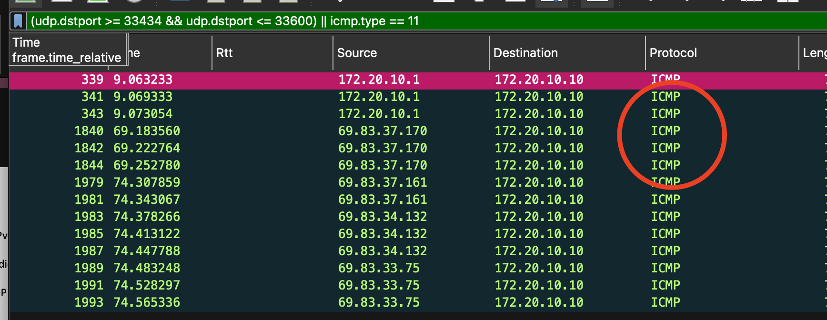

2. IPv4took27 hopsandIPv6took22 hops**.** The IPv4 path is 5 hops longer than the IPv6 path.

3. For hop 14, IPv6 ≈ 61.07 ms vs IPv4 ≈ 41.53 ms and for hop 12, IPv6 ≈ 57.88 ms vs IPv4 ≈ 40.36 ms. One possible reason for the difference is due to different routing domains on v6. The v6 path shows AT&T/Google v6 prefixes, while v4 went through Verizon/AlterNet before Google.

4. For IPv4, the TTL is 1 and the other values are 0x00 → DSCP: CS0, ECN: Not-ECT. For IPv6, the Flow Label is 0x70000, the Traffic Class is 0x00 (DSCP CS0, ECN Not-ECT). Both things prevent packets from looping endlessly in the network by limiting how many hops they can take.

5. The * entries means that one or more routers did not send a response. One reason for this is because of ICMPv6 Time Exceeded errors.

# 4 AI Use Reflation Statement

I used ChatGPT to help explain some of the concepts of the lab like UDP, and IPv4 vs IPv6. I also used it to help generate Wireshark commands that could filter down to relevant packets that I wanted to find. I wrote all of the answers in this report. I found that ChatGPT was good at high level explanations, but it did hallucinate some non-existent features in Wireshark.

**By writing this reflection, I acknowledge that AI is a support tool, not a substitute for my own effort, and I take full responsibility for the final submission.**